**YOGI CHEN PIC- OFFERINGS TO DRAGON KING IN CA & INTRO TO YOGI CHEN**

**A Brief Introduction of Buddhist Yogi C. M. Chen**

Yogi Chen (1906-1987) learned and practiced Hinayana, Mahayana and Vajrayana Buddhism under the guidance of 37 Buddhist teachers. He traveled to Tibet and Xi Kang (Kham) to study Tantric Buddhism for five years. He practiced solitary retreat in two caves for three years in Hunan, China. He was in retreat in one room for 25 years in Kalimpong, India. In 1972 he was invited to Berkeley, California, USA, and stayed there till his Parinirvana.

For a brief but in depth autobiography of Yogi Chen, please read the [Introduction](http://www.yogichen.org/intro_e.html#intro_e) to his work Buddhist Meditation.

He conducted many tantric rituals to benefit all beings and distributed freely books and booklets in English and Chinese to Buddhist organizations and individuals all over the world for over thirty years. Based on his life-long devoted practice and service, Yogi Chen attained deep spiritual accomplishments and unifies the three yanas by his insight of the theory and practice of Buddha Dharma. His works encompass teachings and practices of Hinayana, Mahayana and Vajrayana. He provides many direct, succinct but in-depth teachings based on his own experiences.

"The Complete Works of Yogi Chen" has been edited by his disciple Dr. Lin and is authorized by Dr. Lin to be published and sold at cost by Yuan Ming Publications, Taipei, Taiwan. Currently the first 24 volumes of the whole 37 volume set are in print and they are all in Chinese. After the publishing of the first 24 volumes, Dr. Lin has stopped supporting this project because of the disappointing progress by Yuan Ming Publications. Compilation of Yogi Chen's Collected Works has been done up to 48 volumes. All works of Yogi Chen will gradually be made available on this website in the fu

At one time when I was half awake, the Dakini of Heruka came to me and said, “Go to Si Chuan.” And so I went there, to get detailed teachings of the Vajrayana. I could only go if there was some source of income so it was fortunate that I got a chance just on the date after I heard the Dakini’s command. A secretary of General Government due to the war was evacuated there. I was promised to fill up in it. When I arrived there, he was absent for seven days. I was without money, so I used this opportunity for solitary meditation. While I meditated, the five sisters, emanations of the Buddha Amitayus, told me to go to Xi Kang but without support how could I go? When my superior returned, I asked him if he would help me, and generously he gave me about $200 in Chinese money. With this I set out for Xi Kang where on the snow mountain I received instruction from the famous Ganga Guru. I stayed with him practicing his teachings constantly until my money ran out, in all one hundred days. In a dream experienced in this place Karmapa Rinpoche appeared to me and commanded me to come to him, but for this I would have tried to go to Dege. For funds my guardian deity Wei Tuo, in Tibet identified with Vajrapani, who will be the last of a thousand Buddhas to appear in this auspicious aeon, promised me four myriad Chinese dollars. (Mr. Chen laughed heartily at the memory saying): What and where could I do with so much money? When I left there, I counted the income and goods; the expense were equal to such a sum. I should gratefully give thanks to him. Whenever I got almsgiving, he would appear on a bank note which had been received. Before I arrived at Dege I had a vision one night of Khyentse Rinpoche who was the teacher of young Karmapa, the king of Dharma, and I knew at once that he was an emanation of Mahakala. When we met later in Dege I told him that I knew of his spiritual eminence and rather surprised he admitted that he was practicing in the meditation of Mahakala. He asked me how I knew and after I had told him, he was very pleased and said I was truly his disciple. Ven Khyentse instructed many other Rinpoches but he gave to me many special teachings, other than what he imparted to them.

**How and when did the meditation on the 16th Karmapa appear?**  
It was given after the 16th Karmapa’s escape from the Chinese in 1959. At that time, a lama from Bir in the Western Himalayas asked the 16th Karmapa several times to pass on something meaningful, powerful, and short for the new world. It worked! No Tibetan meditation is used as much in the West as this one.

**Is it possible to reach enlightenment just by doing this very meditation?**

To quote the Great Yogi Chen, a highly accomplished teacher of Hannah and myself who did not leave his home in Kalimpong for 21 years, “When male and female essences are balanced in a lama, any meditation on him is Maha-Annuatara-Yoga-Tantra, the fourth and highest initiation level.” In this case, any practice identifying with the teacher may bring the highest level of accomplishment. Since not all Karmapas were monks, bliss and space are inseparable in his transmission. Called “de-tong” in Tibetan, it is the heart of our Diamond Way and my own daily practice. After having taken refuge in the morning, such identifications are the best for building up energy and moments of insight during the day.

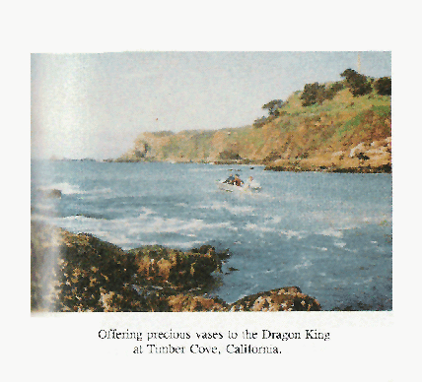

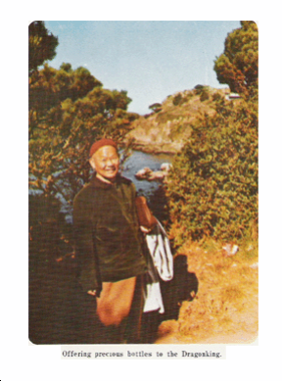

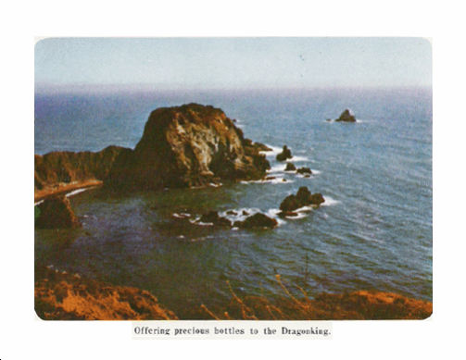

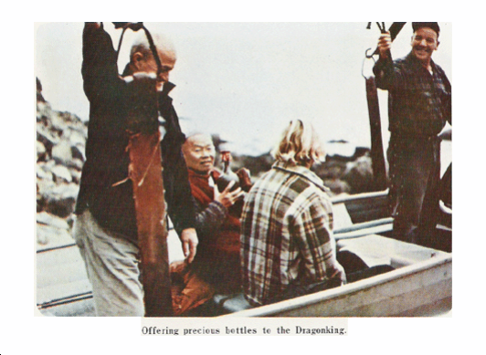

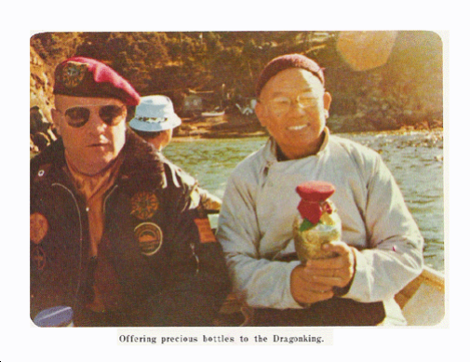

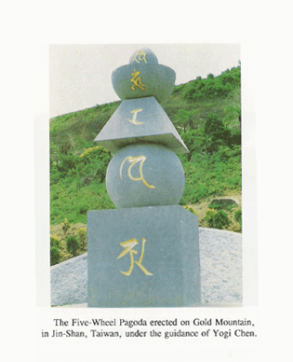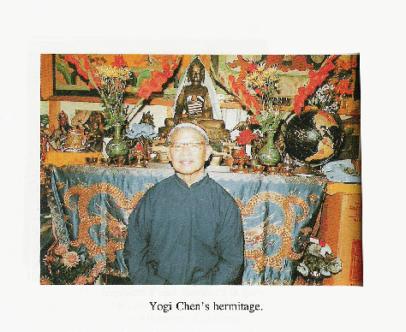

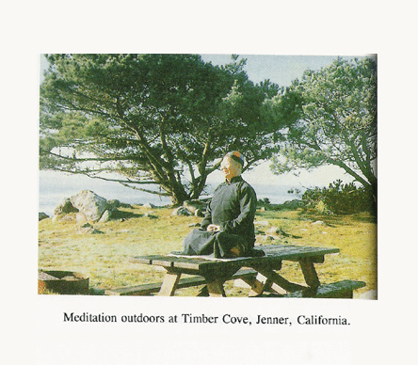

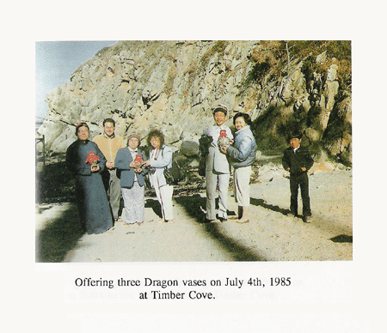

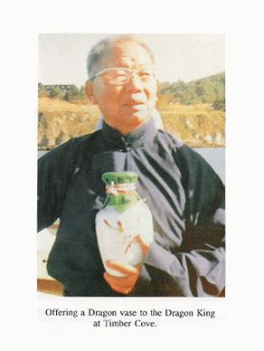

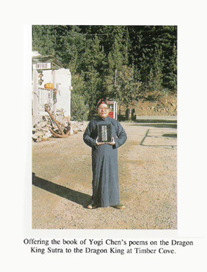

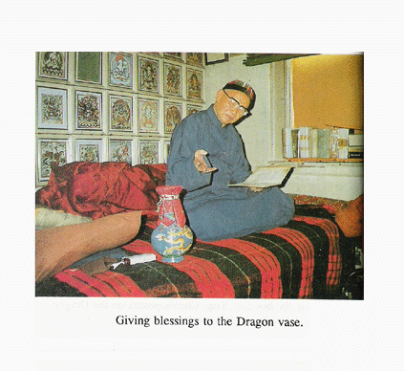

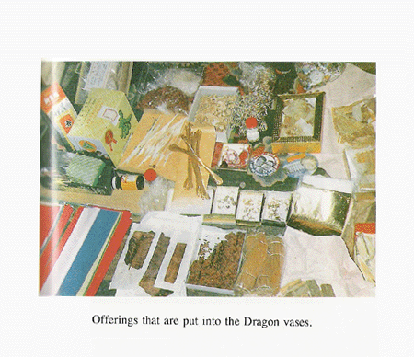

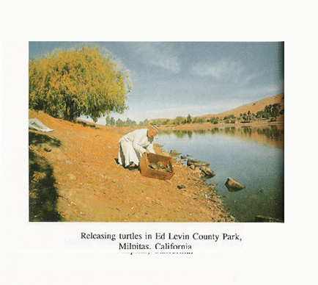

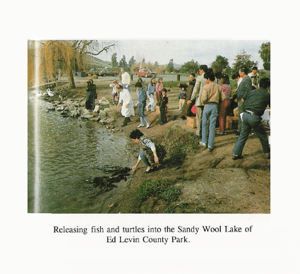

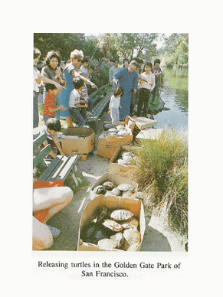

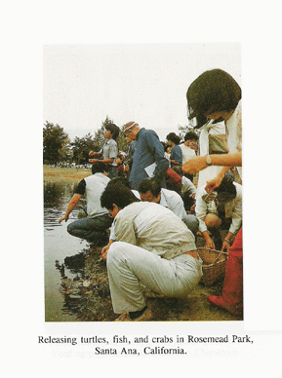

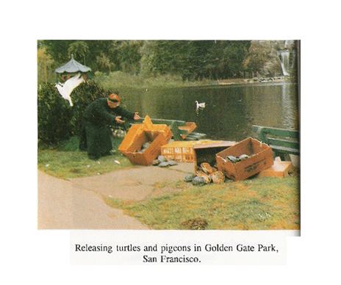

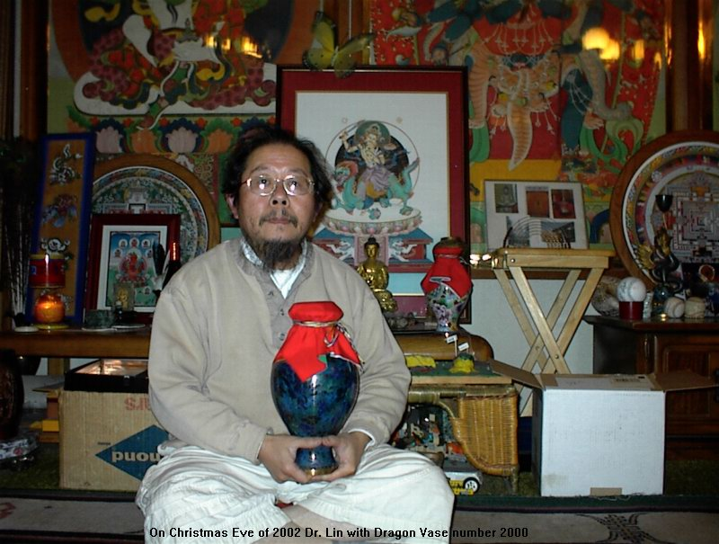

Dr. Yutang Lin

[www.originalpurity.org](http://www.originalpurity.org/" \o "Website of Buddhist Yogi CM Chen Dharma Lineage of Adi Buddha Mandala" \t "_blank)

# [Website of Buddhist Yogi CM Chen Dharma Lineage of Adi Buddha Mandala](http://www.originalpurity.org/" \o "Website of Buddhist Yogi CM Chen Dharma Lineage of Adi Buddha Mandala" \t "_blank)